MED D - Coordination of Benefits (COB) - Letter Response

Overview
COB Letter Response Process (Beneficiary Calling due to a COB Letter Received)
Related Documents

Description: This document provides the steps to use when receiving a call from a beneficiary regarding a Coordination of Benefits (COB) letter.

Note: If calling due to a claim rejection, refer to MED D - Coordination of Benefits (COB) - Claim Rejection.

Overview
Coordination of Benefits (COB) occurs when Medicare beneficiaries have other prescription drug coverage in addition to Medicare Part D coverage. CMS requires Part D sponsors to coordinate benefits with other prescription drug coverage for several reasons, including:
- Avoid duplication of payment
- Possibly reduce beneficiary’s co-pay at point of sale
- Prevent Medicare from paying primary when it is the secondary payer
- Protection against high out-of-pocket expenditures
- Properly track TrOOP dollars when a supplemental payer contributes

Part D Sponsor obtains Coordination of Benefits information in a few ways:
- File from CMS (COB File)
- COB Letter
- Beneficiaries/Pharmacies advising other coverage exists.

When the Part D sponsor is notified of a change to the other coverage on file, an update needs to be submitted to CMS electronically. COB records are updated on an on-going basis to reflect the most accurate Other Health Information (OHI).

Top of the Document

COB Letter Response Process (Beneficiary Calling due to a COB Letter Received)
Beneficiaries enrolled into a Medicare Part D plan may call into MED D Customer Care in response to a COB Letter he/she has received:
- Upon a New Enrollment.
- Annual COB Notification.
- Unmatched N1 Letter.

Note: COB Letters are sent to beneficiaries for verification of Other Health Insurance (OHI) on file. Beneficiary will call to:
- Verify information is correct
- Advise information is invalid
- Provide correct or new information

If the beneficiary is calling to respond to a COB letter we mailed, it is the CCR’s responsibility to submit the RM Task to the COB team for research. This does not require assistance from Senior Team.

Perform the following steps:
Step | Action
1 | Review the Coordination of Benefits tab on the Main Screen (Participant Inquiry tab) in PeopleSafe  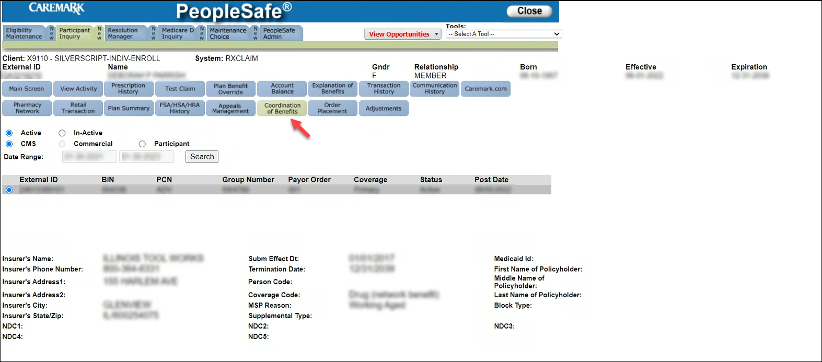
2 | Determine the COB letter the beneficiary is referencing  An image of the beneficiary’s Coordination of Benefits (COB) Letter will be viewable in the ONECLICK system, accessible under the Med D Inquiry Tab in PeopleSafe.  Reference: MED D - Viewing Correspondence and Requesting Reprints in PeopleSafe as needed.  Event Code – Indicates Letter Type  - DCOBE – New Enrollee with COB information on file  - DCOBI – Beneficiary indicated COB is present on enrollment form, but there was insufficient information provided  - DCOBA – Annual Mailing of MedD beneficiaries with COB information on file.  - DCOBN – Pharmacy billed other coverage as secondary, however, we do not have COB information on file.  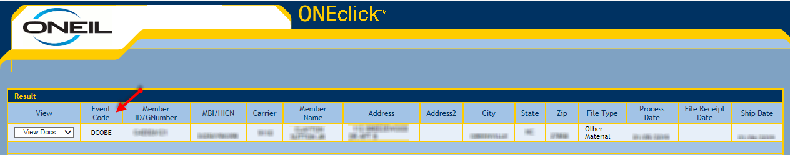
2 | If the beneficiary says… | Then the CCR will…
2 | I have coverage that needs to be added or updated | Please ensure the COB information the beneficiary is providing is not their primary Medicare coverage.  CCR will submit a request to the COB team through RM Task to research/update the COB information using the following option:  - Task Category: Billing/Payment  - Task Type: Premium Billing Inquiry Medicare D  - Queue: Finance – Scottsdale Premium Billing  - Amount Disputed: “0000”  - Reason for Dispute: Coordination of Benefits  Include the following verbiage and information within the Beneficiary Comments.  - Update COB Coverage, Add Primary Coverage, Add Secondary Coverage, Add Other Coverage.  - Include the Other Health Information to be updated  - ID, BIN, PCN, GROUP, Insurance Name, Effective Date and/or Term date of Coverage.  Note: Turn Around Time will vary.
2 | I have coverage that needs to be added or updated but I am unable to remember what coverage I have | Advise the beneficiary to contact the Medicare Benefits Coordination & Recovery Center, BCRC at 1-855-798-2627. (Monday – Friday, 8:00 a.m. to 8:00 p.m., Eastern Time, except holidays).
2 | I do not have the insurance provided on the letter and/or remove this coverage on file | The CCR will submit a request to the COB team through RM Task to research/update the COB information using the following option:  - Task Category: Billing/Payment  - Task Type: Premium Billing Inquiry Medicare D  - Queue: Finance – Scottsdale Premium Billing  - Amount Disputed: “0000”  - Reason for Dispute: Coordination of Benefits  Include the following verbiage and information within the Beneficiary Comments.  - Remove COB Coverage  - Include the ID and Insurance Name that needs to be deleted  Note: Turn Around Time will vary.
If urgent review or unable to resolve beneficiary inquiry through an RM task, warm transfer the call to the Senior Team as a Procedural Transfer. Refer to MED D - When to Transfer Calls to the Senior Team.
- The Senior Team will:
  - Submit an email to COB.Operations@CVSHealth.com with ACCESS TO CARE - SECUREMAIL in the subject line and CC’ the Solon Senior Follow-Up Team SolonSeniorFollowupT@cvscaremark.com.
- In order to ensure a follow up call, warm transfer to the Case Coordinator Line 855-771-9283.

Top of the Document

Related Documents
Grievance Standard Verbiage (for use in Discussion with Beneficiary) section in MED D - Grievances Index

Parent SOP: CALL-0048: Medicare Part D Customer Care Call Center Requirements-CVS Caremark Part D Services, L.L.C.
Abbreviations/Definitions: Abbreviations / Definitions

Top of the Document

Not to Be Reproduced or Disclosed to Others without Prior Written Approval
ELECTRONIC DATA = OFFICIAL VERSION – PAPER COPY = INFORMATIONAL ONLY

